Sadie Barnett-Boudreau                                                                  Thursday, August 27th, 2020

Rice University Data Analytics & Visualization Bootcamp

Pandas-Challenge

Heroes of Pymoli



Player Count: 576

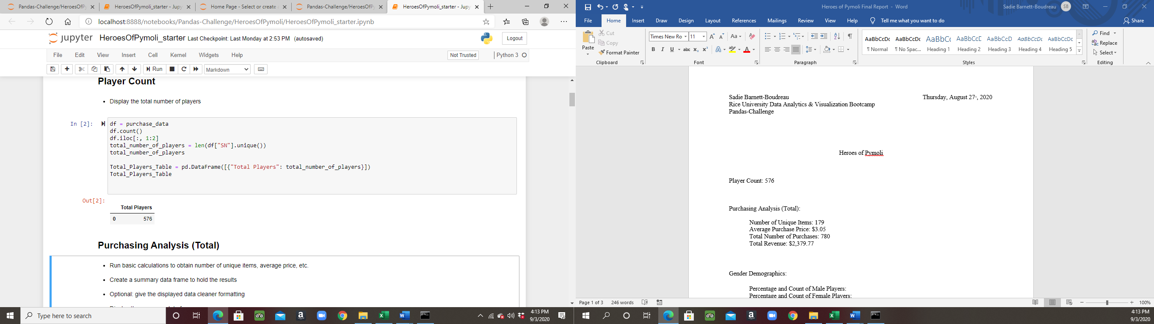

Purchasing Analysis (Total):

Number of Unique Items: 179

Average Purchase Price: $3.05

Total Number of Purchases: 780

Total Revenue: $2,379.77

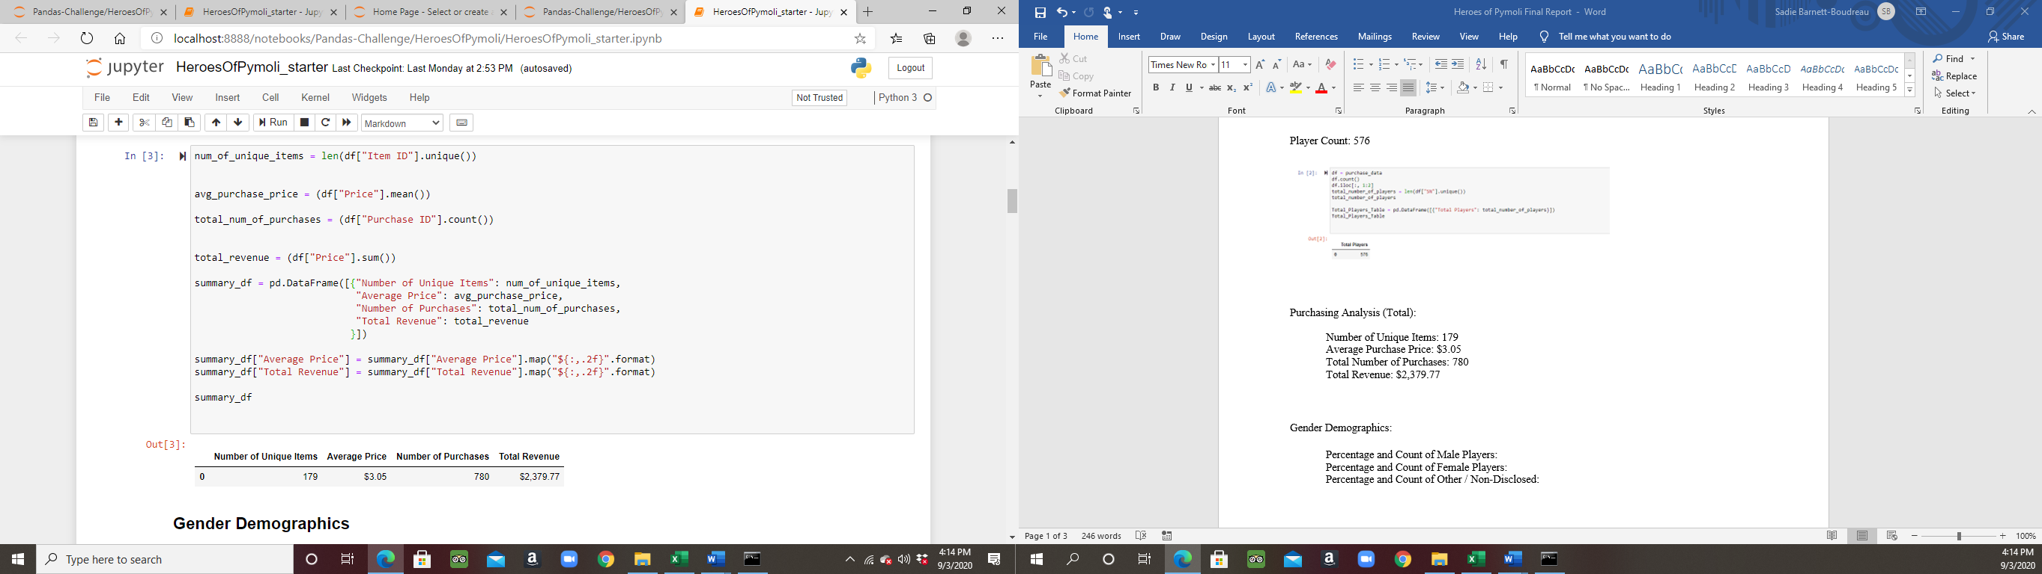

Gender Demographics:

Percentage and Count of Male Players: 84.03% | 484

Percentage and Count of Female Players: 14.06% | 81

Percentage and Count of Other / Non-Disclosed: 1.91% | 11

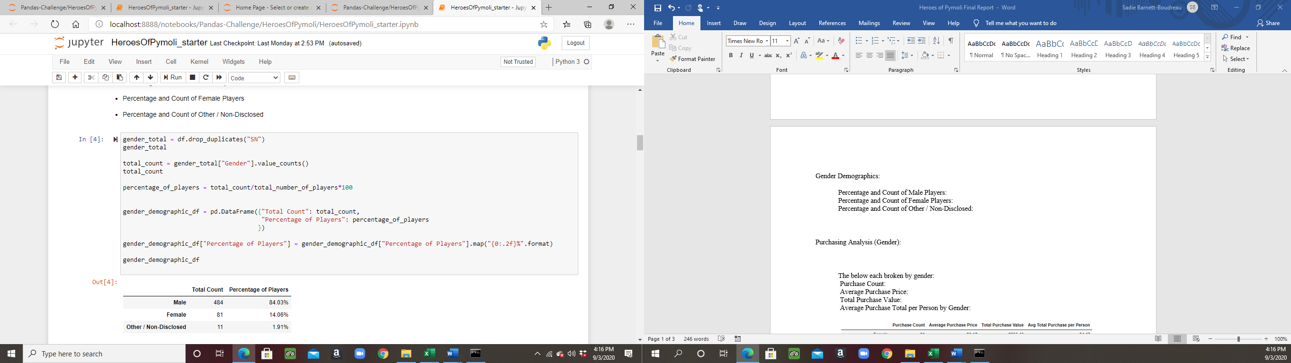

Purchasing Analysis (Gender):

The below each broken by gender:

Purchase Count:

Female: 81

Male: 484

Other/Non-Disclosed: 11

Average Purchase Price:

Female: $3.17

Male: $3.05

Other/Non-Disclosed: $3.41

Total Purchase Value:

Female: $256.43

Male: $1,474.70

Other/Non-Disclosed: $37.52

Average Purchase Total per Person by Gender:

Female: $4.47

Male: $4.07

Other/Non-Disclosed: $4.56

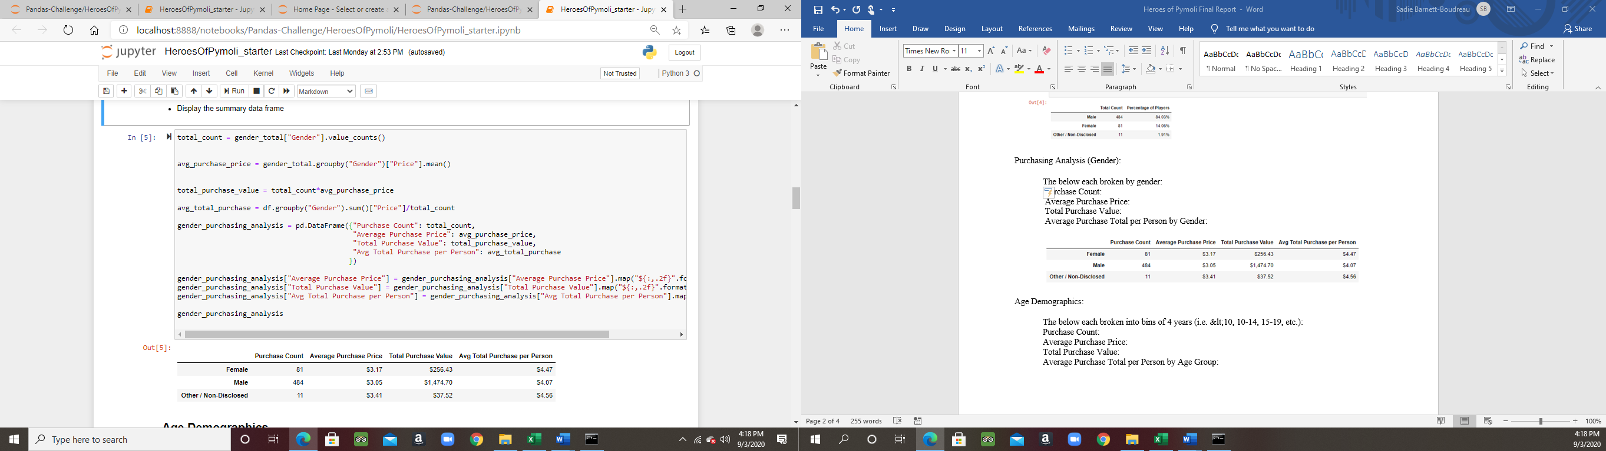

Age Demographics:

The below each broken into bins of 4 years (i.e. &lt;10, 10-14, 15-19, etc.):

Purchase Count:

Average Purchase Price:

Total Purchase Value:

Average Purchase Total per Person by Age Group:

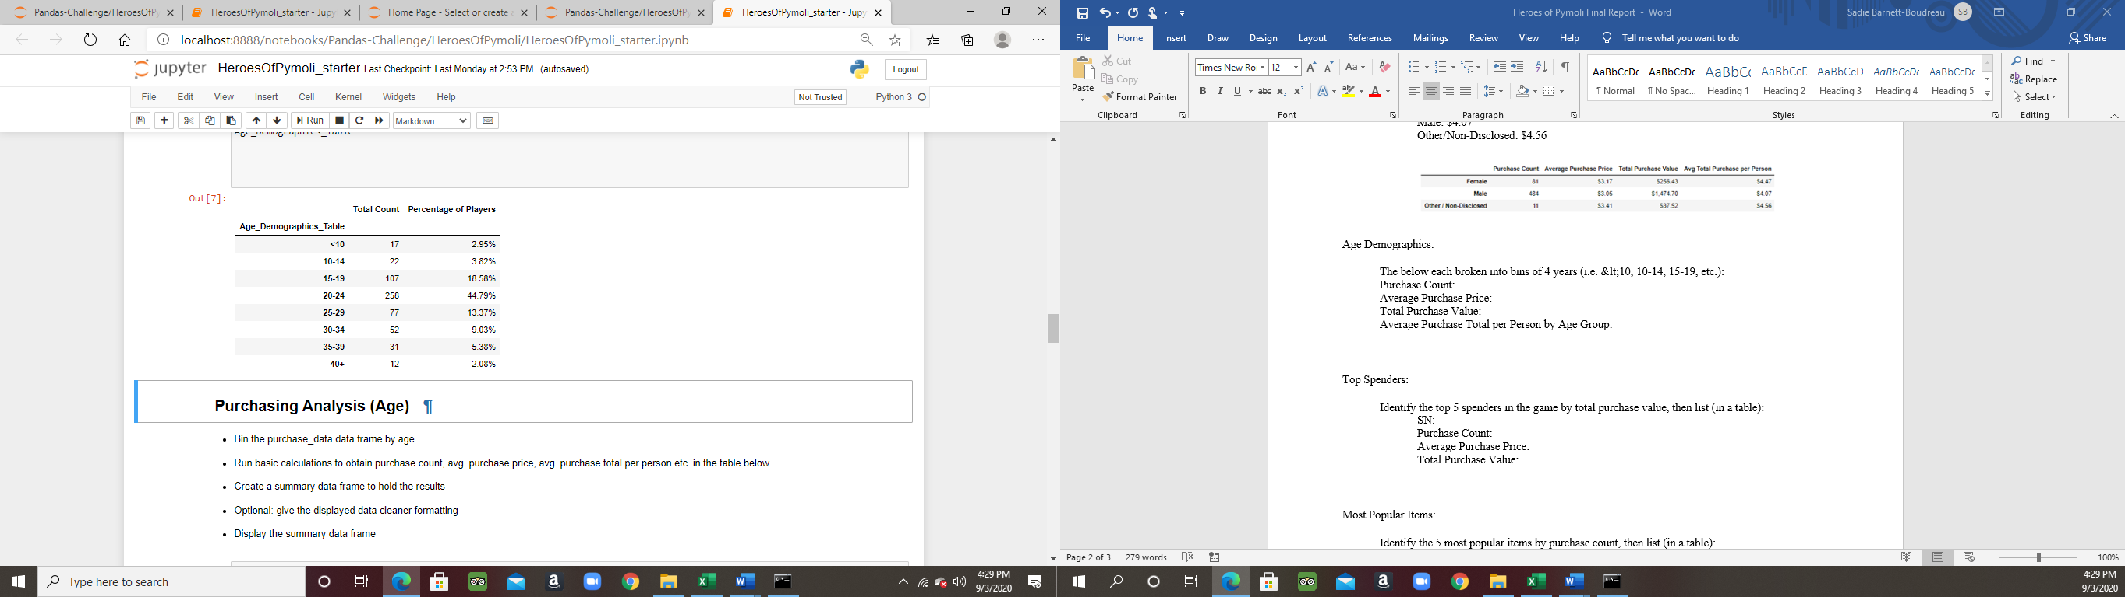

Purchasing Analysis (Age):

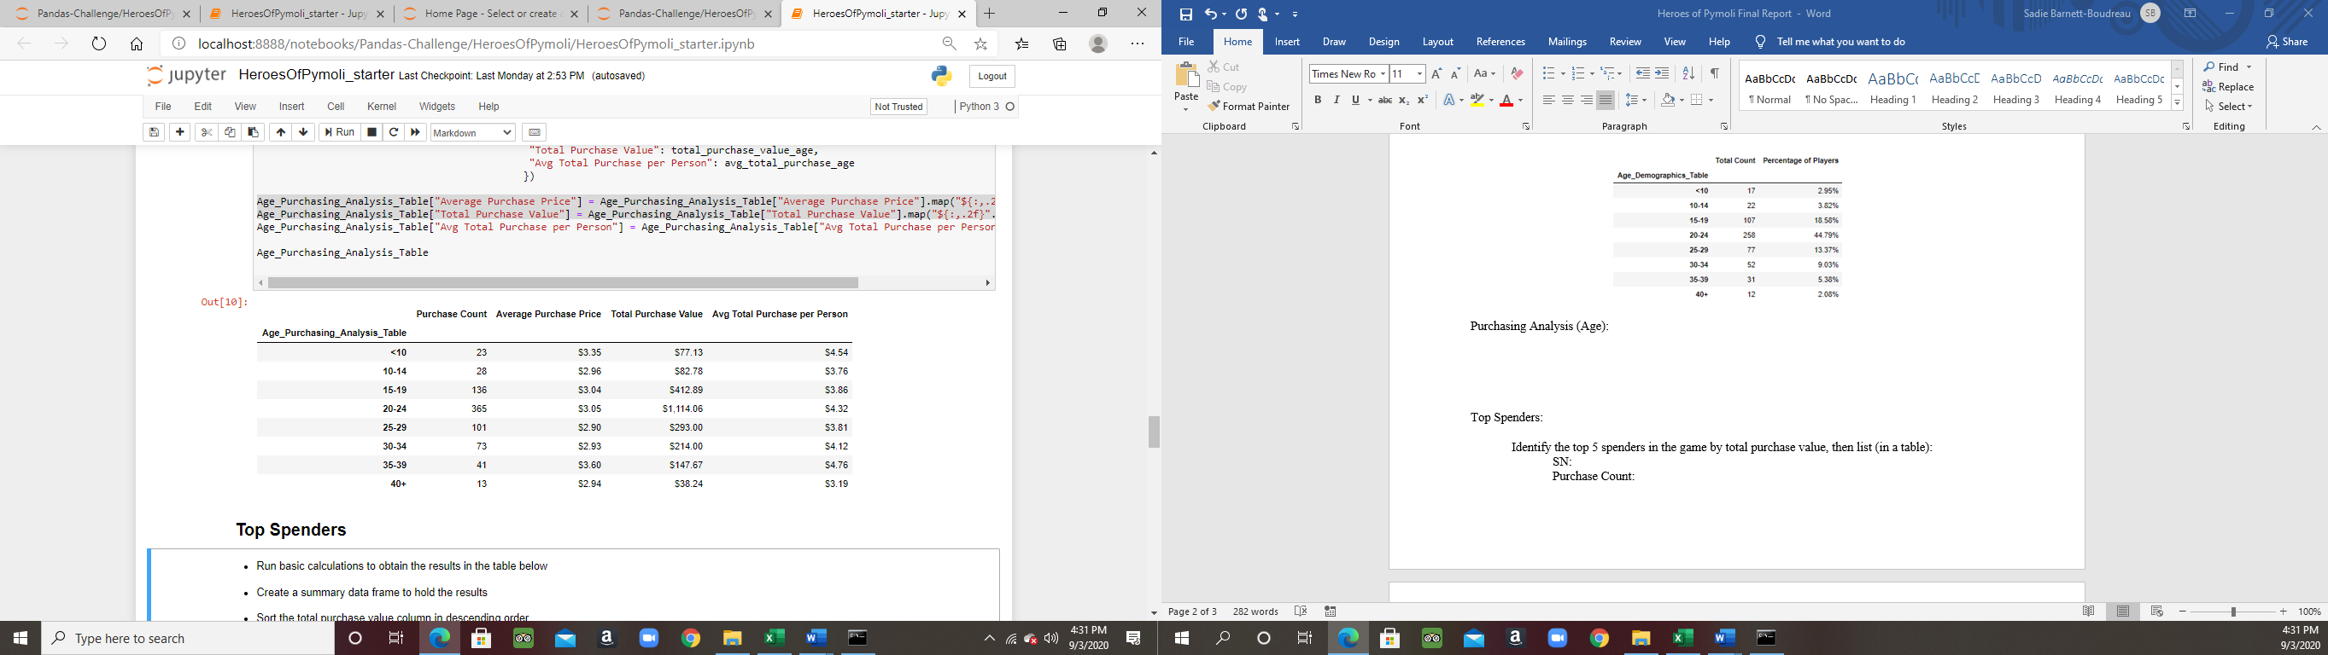

Top Spenders:

Identify the top 5 spenders in the game by total purchase value, then list (in a table):

SN:

Purchase Count:

Average Purchase Price:

Total Purchase Value:

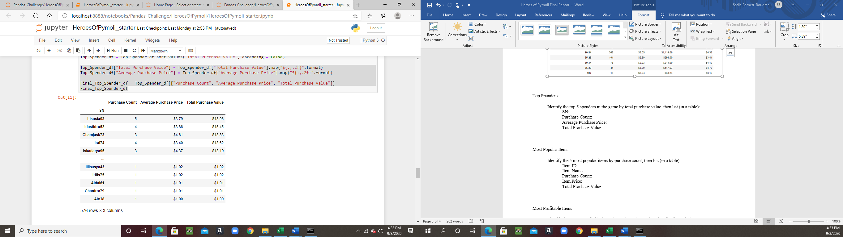

Most Popular Items:

Identify the 5 most popular items by purchase count, then list (in a table):

Item ID:

Item Name:

Purchase Count:

Item Price:

Total Purchase Value:

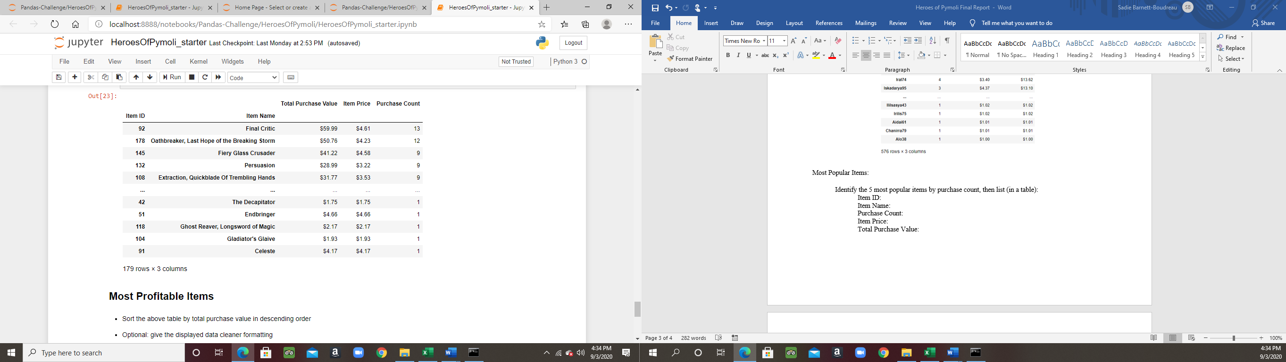

Most Profitable Items

Identify the 5 most profitable items by total purchase value, then list (in a table):

Item ID:

Item Name:

Purchase Count:

Item Price:

Total Purchase Value:

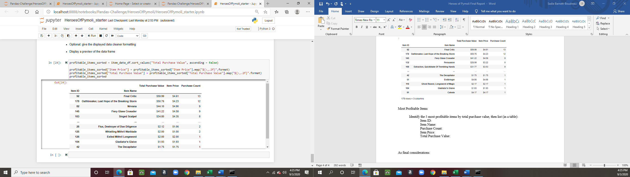

As final considerations:

3 Observable Data Trends:

For this specific data set, sales are dominated by both males, and individuals within the range of 15 to 34 years of age. As evidenced by the Age Demographics Table, individuals within the age range of 20 to 24 years old have too much free time on their hands. Although male players dominated the player count percentage (84.03%), female and non-disclosed players paid higher prices both in game purchase price and total purchase price per person.